**FEE STRUCTURE FOR IAS COACHING AT CLASSIC IAS ACADEMY:**

**ABOUT IAS COACHING COURSE MODULE:**

The coaching course offered by Classic IAS Academy is a fully integrated 12 months Offline and Online (Hybrid) course and covers each and every aspect of the various stages of the examination thereby providing a complete solution to the aspirant. The aspirant is not required to do the parts of the courses separately and thus not required to pay any other extra charges.

However, the **“Optional”** subject courses are conducted and charged separately.

**WHY CHOOSE CLASSIC IAS ACADEMY?**

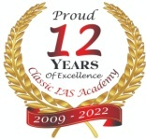**12 Years of Nurturing IAS Aspirants.**

We have been into existence since 2009 and delivering consistent results year on year and the counting is on…….

**Awards & Recognitions**

Have won the following awards and recognitions:

1. Knowledge Resource Development & Welfare Group, IIT Delhi

Margdarshan Awards 2013 for Innovation and Excellence in Coaching

1. Berg Awards For Innovation & Excellence in Education 2014

Singapore in Civil Services Coaching, 2014

1. Royal Brands Awards for Best IAS Academy in North India, 2016
2. Royal Brands Awards for Best Institute in Intellectual Impact in Delhi/NCR
3. Competition Success Review Certificate of Merit for CSR Trophy for Excellence in Coaching, 2016

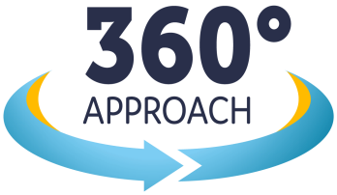**360 Degree approach to cover the whole of the course:**

Our course is fully integrated 12 months course and comprehensively covers all the three stages of Civil Services Exam. No need to pay extra charges other than optional subjects.

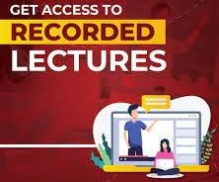**Never Miss a Class:** Recorded video lectures available

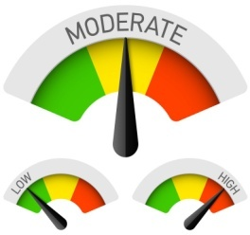**Moderate Batch Sizes:** Our batch sizes are not crowded and are moderate for better interactions, personal attention and are participatory in nature.

**Proven Track Record:** *We have delivered 60+ selections in the year 2021, 80+ selections in the year 2020 exams, 54 selections in the 2019 and 120 in the year 2018.*

**Best in Class Faculty:**

* Our faculty team is the best in class, well qualified, experienced, devoted and confident to hand hold you to the destination.
* Their legacy is from the renowned universities with achievements of distinguished awards and felicitations.
* They are associated with us since long durations and know well about the examination patterns and student psychology.
* They form the part of the competent research team and keep on developing better teaching experiences and are well poised to address the students FAQ’s.
* They focus on to the student gaining knowledge and skills to face the exam confidently rather than academic focus.

**FEE STRUCTURE:**

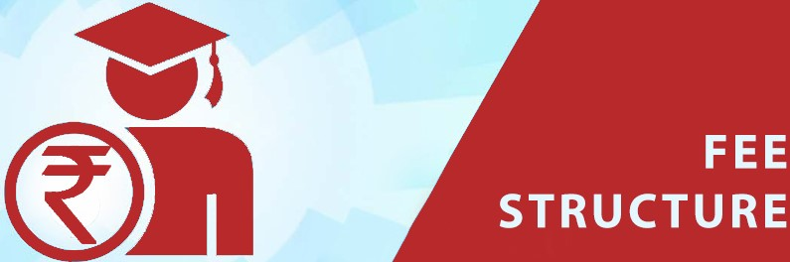

|  |  |  |  |  |  |  |  |  |
| --- | --- | --- | --- | --- | --- | --- | --- | --- |
| **CLASSIC IAS ACADEMY - FEE STRUCTURE - NOV 15th 2022 ONWARDS** | | | | | | | | |
| **S.No** | **Product Category** | **Product Coverage** | **Duration** | **Price (INR)** | **GST-18%** | **Total Price (INR)** | **Registration Amount (INR)** | **Pay Now** |
| 1 | Online Prelims Mock Test Series | Covers 18 Schedule wise Prelims Test Series - GS-1 & GS -2 (CSAT) |  | 5040 | 910 | 5950 | 5950 | **Pay Now** |
| 2 | Offline-Class Room IAS Coaching | Covers General Studies Foundation (Prelims + Mains + Essay + CSAT+ Test Series + Interview Guidance) | 12 Months | 97750 | 17595 | 115345 | 20000 | **Pay Now** |
| 3 | Live Online (Hybrid)-Class Room IAS Coaching | Covers General Studies Foundation (Prelims + Mains + Essay + CSAT+ Test Series + Interview Guidance) | 12 Months | 48940 | 8810 | 57750 | 20000 | **Pay Now** |
| 4 | Optional Courses - Available in Offline & Online Mode | Public Administration, History, Geography, Political Science & International Relations | 4-5 Months | 38135 | 6865 | 45000 | 45000 | **Pay Now** |

For any query related to fee structure, please contact us **9818740741**

**OR**

Write to us at[**helpdesk@classiciasacademy.com**](mailto:helpdesk@classiciasacademy.com)

**OR**

**Visit Us at:**

**Karol Bagh Centre**

**Classic IAS Academy**

GF-16-17, Apsara Arcade,

Pusa Road, Karol Bagh,

New Delhi 110005

**Bhikaji Cama Place (South Delhi) Centre**

Classic IAS Academy

UG-33, Ansal Chamber – 1,

Bhikaji Cama Place,

New Delhi – 110066